**FINAL REPORT**

***SCOUT ROVER***

***(Surveillance and Monitoring)***

**TEAM MEMBER:**

|  |  |  |  |
| --- | --- | --- | --- |
| **REGISTER NO** | **NAME** | **PHONE NO** | **EMAIL ID** |
| 411621243028 | JASWANTH V  **(TEAM LEADER)** | 9150588299 | jaswanthjas2004@gmail.com |
| 411621121016 | MANDALAPU SAMANTHA | 9342389687 | mandalapusamantha0@gmail.com |
| 411621104006 | BARKAVI E | 9677554607 | barkavikannan951@gmail.com |
| 411622243013 | HEMANTH RAJ G | 9791134881 | mugilnath@gmail.com |
| 411622243030 | SANTHOSH S | 7200783027 | santhosh.yadhav.308@gmail.com |

**Faculty mentors**

1. ***Mrs. M. Anitha M.E***
2. ***Miss. B. Sivadharahini M.E***

**PRINCE DR. K. VASUDEVAN COLLEGE OF**

**ENGINEERING AND TECHNOLOGY, PONMAR,**

**CHENNAI-600122**

Date:10/05/2024

# **ABSTRACT**

*The "Scout Rover" is an advanced IoT-enabled vehicle designed for surveillance and reconnaissance in disaster environments, particularly tunnels. It addresses the critical need for real-time situational awareness in hazardous conditions, enhancing the safety and efficiency of rescue operations. The rover is equipped with a suite of sensors, including air quality monitors and cameras, to provide live video feeds and continuous monitoring of environmental conditions. Operated remotely, the Scout Rover offers precise navigation through treacherous areas, allowing rescue teams to assess risks without direct exposure. Our development achieved a compact, modular design that ensures adaptability to various disaster scenarios, making the Scout Rover a versatile tool in crisis management. This innovation stands to significantly improve disaster response, safeguarding human lives by providing essential data and insights for informed decision-making.*

# **TABLE OF CONTENTS**

1.Introduction…………………………………………………………………………………4

1.1 Problem Definition………………………………………………………..............5

2.Proposed Solution/Concept…………………………………………………………………5

2.1 Conceptual design 1………………………………………………………………5

2.2 Conceptual design 2………………………………………………………………6

2.3 Conceptual design 3………………………………………………………………7

3.Design details………………………………………………………………………………10

4.Timeline……………………………………………………………………………………18

5.Implementation…………………………………………………………………………….19

6.Conclusion………………………………………………………………………………….21

7. Acknowledgments………………………………………………………………………...24

8.Reference…………………………………………………………………………………..25

**INTRODUCTION**

*The "Scout Rover" is a cutting-edge IoT-enabled vehicle engineered for surveillance and reconnaissance in disaster environments, particularly tunnels. Equipped with a suite of sensors, including air quality monitors and cameras, it provides live video feeds and continuous environmental monitoring. Its primary function is to navigate through hazardous areas remotely, offering real-time situational awareness and critical data to aid disaster response efforts. The Scout Rover addresses the urgent need to enhance safety and efficiency in disaster operations by entering perilous zones first, gathering essential information, and providing insights to guide rescue efforts, thereby ensuring responder safety and improving disaster management effectiveness. The primary beneficiaries are emergency response teams such as firefighters and search and rescue units, who can obtain crucial real-time data without exposing personnel to danger. The broader community benefits from quicker, more informed disaster responses, potentially saving lives and reducing infrastructure damage. The innovative aspect of the Scout Rover lies in its integration of IoT technology with a modular and adaptable design, combining advanced sensors with remote operation capabilities. Its compact design enables easy customization and upgrades, while Bluetooth and WiFi connectivity expand its operational range and data transmission capabilities, making it a robust solution for modern disaster response challenges.*

## PROBLEM DEFINITION

*The proposed Scout Rover will provide real-time surveillance and environmental monitoring in disaster environments, particularly tunnels, by utilizing a suite of sensors and cameras. It will enhance the safety and efficiency of rescue operations by remotely gathering critical data and offering situational awareness without exposing personnel to hazardous conditions.*

**CONCEPTUAL DESIGN**

**Conceptual Design 1: Wired Control with Wi-Fi Camera Streaming**

**(ESP32-CAM)**

**Description:** *This design enhances the Scout Rover's capabilities by enabling wired control through a medium controller while leveraging the ESP32-CAM's Wi-Fi capabilities for live video streaming. In this configuration, operators can utilize a wired medium controller to send precise control commands to the Rover, ensuring stable and low-latency maneuvering in various environments. Meanwhile, the ESP32-CAM module streams real-time video over Wi-Fi to the control station, providing operators with crucial visual feedback for tasks such as search and rescue, environmental monitoring, and security operations. By combining wired control with wireless video streaming, this design offers the best of both worlds: reliable, responsive control and flexible, real-time situational awareness. Operators can monitor live video feeds and issue commands through an intuitive user interface, optimizing the Rover's performance and mission success across diverse applications.*

**BLOCK DIAGRAM**

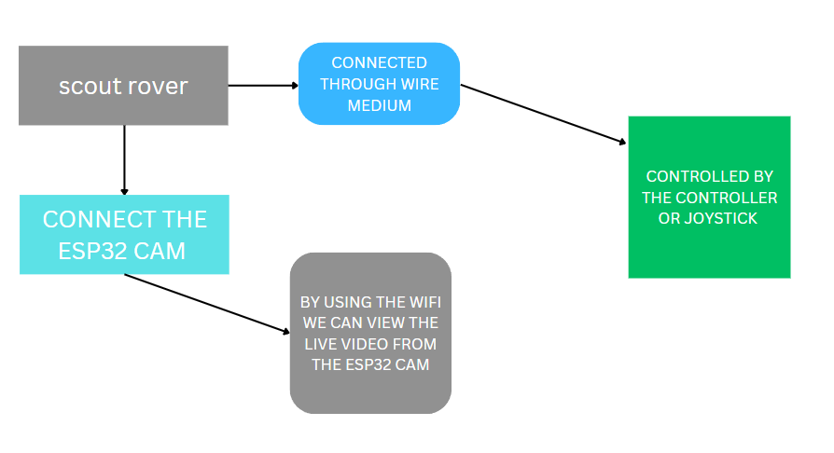

**Conceptual Design 2: Multi-Sensor Integration with ESP32-CAM**

***Description:*** *In this design, the Scout Rover integrates various sensors—temperature, pressure, air quality, and humidity—alongside the ESP32-CAM for video streaming and communication. This configuration enables the rover to gather extensive environmental data while offering live video feedback. The amalgamation of these sensors empowers the rover to evaluate diverse environmental conditions, heightening situational awareness crucial for disaster response scenarios. The ESP32-CAM module facilitates real-time video streaming over Wi-Fi to the control station, pivotal for monitoring and navigation. Control commands are reliably transmitted via a wired connection, ensuring stable maneuvering even in environments with notable wireless interference. Operators at the control station receive both live video and detailed environmental data from the rover, pivotal for tasks such as search and rescue, environmental monitoring, and security. Understanding ground conditions profoundly impacts mission success. By amalgamating the flexibility of Wi-Fi video streaming with the dependability of wired control and the comprehensive sensor data, the Scout Rover is adeptly equipped for operation in challenging environments. This capability enhances its efficacy in supporting critical operations and improving outcomes across various demanding applications.*

**BLOCK DIAGRAM:**

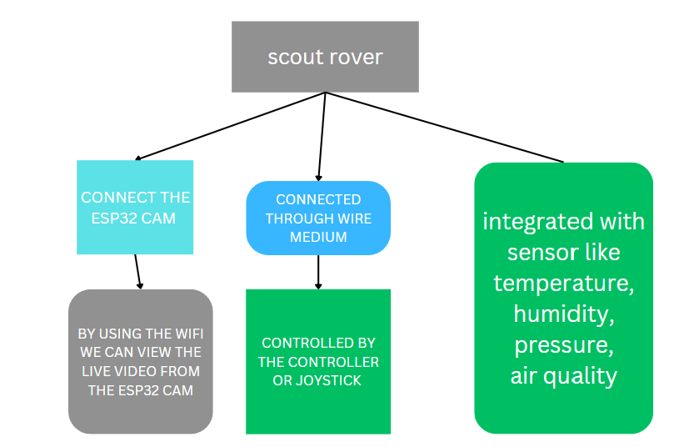

**Conceptual Design 3: Bluetooth-Controlled Rover with ESP32-CAM and Air Quality Sensor**

*The "Scout Rover" is an innovative IoT-enabled vehicle designed to navigate disaster areas, particularly tunnels, providing critical surveillance and reconnaissance capabilities. Equipped with a suite of sensors including air quality monitors and human detection cameras, the rover enters disaster zones to assess the situation remotely. Its primary function is to display live video feeds and monitor air quality, ensuring the safety of rescue teams and survivors. The Scout Rover operates under human control, allowing precise navigation through hazardous environments. It serves as a frontline tool for disaster response, providing real-time data and situational awareness to aid decision-making. The rover's compact design and modular sensor platform enhance adaptability to various disaster scenarios, offering a versatile solution for crisis management. With its ability to explore and monitor disaster areas, the Scout Rover stands as a crucial asset in mitigating the impact of emergencies and safeguarding human lives.*

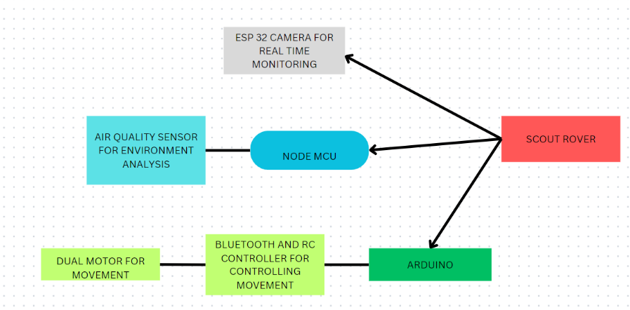

| **Criteria** | **Conceptual Design 1** | **Conceptual Design 2** | **Conceptual Design 3** |
| --- | --- | --- | --- |
| Control Method | Wired | Wired | Bluetooth |
| Communication Technology | Wi-Fi | Wi-Fi | Wi-Fi, Bluetooth |
| Sensor Integration | Video streaming (ESP32-CAM) | Multi-sensor (including ESP32-CAM) | Air quality sensor, Video streaming (ESP32-CAM) |
| Application Focus | Search and rescue, Environmental monitoring, Security | Environmental monitoring, Disaster response | Disaster response, Surveillance, Air quality monitoring |
| Importance | Stable control, Flexible video streaming | Extensive environmental data collection | Real-time air quality monitoring, Enhanced situational awareness |

**DESIGN SELECTION TABLE:**

*By evaluating these criteria, Conceptual Design 3 stands out for its unique focus on disaster response, surveillance, and air quality monitoring. Here's why it's important:*

*Conceptual Design 3 offers a specialized solution catering to disaster response, surveillance, and air quality monitoring applications. By incorporating an air quality sensor alongside the ESP32-CAM for live video streaming, the Scout Rover becomes equipped for real-time air quality monitoring in disaster areas. This capability is crucial for assessing environmental safety and minimizing health risks for both rescue teams and survivors. Additionally, the integration of Bluetooth for control enables remote maneuvering of the Rover, enhancing its flexibility and adaptability in dynamic disaster scenarios. Conceptual Design 3 prioritizes real-time air quality monitoring and enhanced situational awareness, making it a valuable asset for disaster response teams and surveillance operations in challenging environments.*

**DESIGN DETAILS**

**1. System-Level Design Aspects:**

* *The Scout Rover is designed to be an IoT-enabled vehicle for surveillance and analysis in disaster environments.*
* *It incorporates a robust chassis, equipped with sensors for air quality monitoring, human detection cameras, and motor control for navigation.*
* *The system operates under human control, ensuring precise navigation through hazardous environments.*
* *It provides live video feeds and monitors air quality to ensure the safety of rescue teams and survivors.*

**2. Mechanical Aspects of the Design:**

* + *The chassis is constructed using a 4-wheel chassis kit, providing stability and support for mounting various components.*
  + *Components such as the battery holder, motors, wheels, and sensor mounts are securely integrated into the chassis.*
  + *The design prioritizes durability and adaptability to different terrain conditions encountered in disaster environments.*

**3. Orthographic and Isometric Projections:**

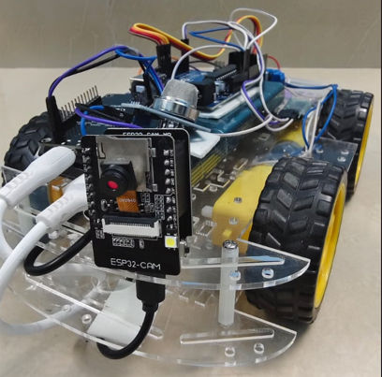

Isometric projection

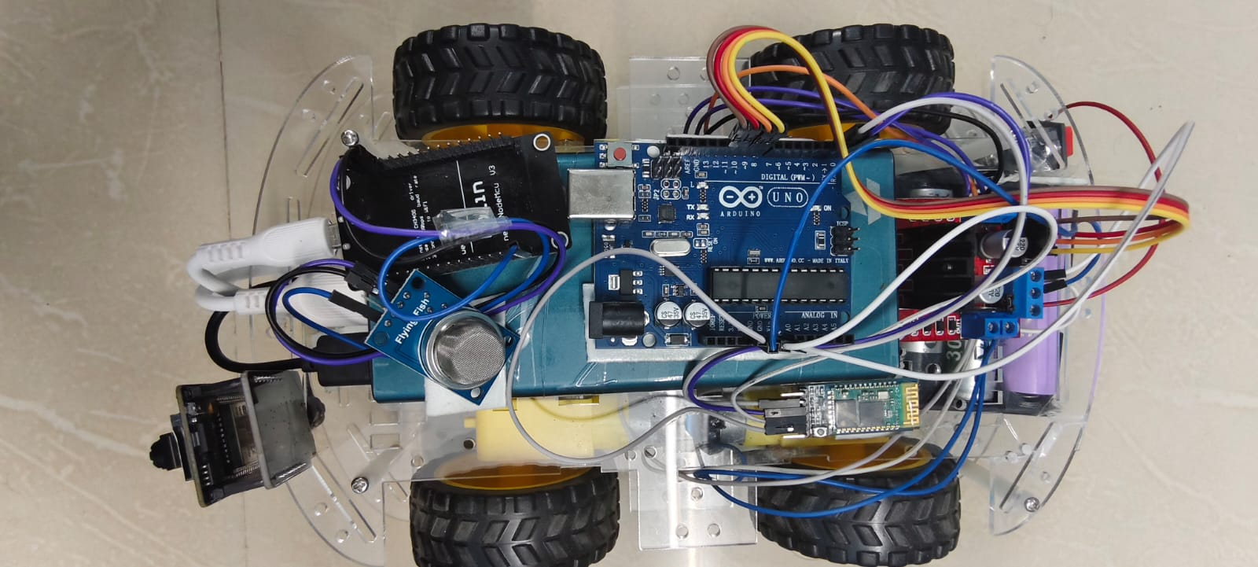

Top view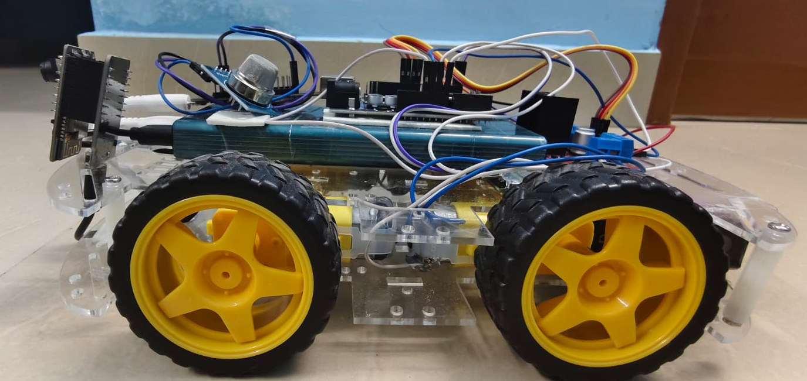

Side view

**4. Working and Design Explanation:**

**1. Bluetooth Control (HC-05):**

***Working:*** *The HC-05 module establishes a Bluetooth connection with your phone using the "RC Controller" app. The app sends control signals to the HC-05, which are then interpreted by the rover's microcontroller (likely an Arduino or similar). Based on the received commands (e.g., forward, backward, left, right), the rover's motors are activated accordingly, allowing you to remotely control its movements.*

***Design Explanation:*** *This stage enables wireless control of the rover via Bluetooth technology. The HC-05 module serves as the interface between your phone and the rover, facilitating bidirectional communication for sending control signals and receiving feedback.*

**2. Wi-Fi Video Streaming (ESP32-CAM):**

***Working:*** *The ESP32-CAM captures live video footage using its onboard camera and streams it over a Wi-Fi network. Your phone's Wi-Fi hotspot provides the network connection, allowing you to access the live video feed through a compatible app or web browser on your phone.*

***Design Explanation:*** *This stage leverages Wi-Fi technology for real-time video streaming from the rover to your phone. The ESP32-CAM module serves as the video capture device, while your phone's Wi-Fi hotspot serves as the communication channel for transmitting the video data.*

**3. Air Quality Monitoring (ESP8266/Nodemcu):**

***Working:*** *The ESP8266 (Nodemcu) gathers air quality data from sensors (e.g., gas sensors, particulate matter sensors) and transmits it to the internet via Wi-Fi. The data is sent to ThingSpeak, a cloud-based platform, where you've created a channel to visualize and analyze the air quality data in graphical form.*

***Design Explanation:*** *This stage involves monitoring air quality using sensor data and transmitting it to the internet for analysis and visualization. The ESP8266 (Nodemcu) serves as the data acquisition and transmission device, while ThingSpeak provides the platform for data visualization and analysis.*

**5. Electrical Aspects of the Design:**

***1. Power Management:***

*- Ensure that each component of your project receives stable and appropriate power.*

*- Use voltage regulators or buck-boost converters to regulate voltage levels if necessary.*

*- Implement proper power distribution to prevent overloading any part of the system.*

**2. Battery Management:**

*- If using a lithium rechargeable battery for the rover, incorporate a battery management system (BMS) to protect against overcharging, over-discharging, and short circuits.*

*- Use a charging circuit to safely recharge the battery.*

**3. Motor Control:**

*- Use motor drivers or H-bridges to control the rover's motors.*

*- Implement motor control algorithms to ensure smooth and efficient operation.*

**4. Microcontroller Integration:**

*- Interface microcontrollers (such as the ESP32 and ESP8266) with sensors, actuators, and communication modules.*

*- Use appropriate communication protocols (such as UART, SPI, I2C) to communicate between microcontrollers and peripherals.*

**5. Bluetooth Module (HC-05):**

*- Interface the HC-05 Bluetooth module with the rover's microcontroller for wireless control.*

*- Implement reliable communication protocols to ensure accurate transmission of control signals.*

**6. Wi-Fi Modules (ESP32-CAM, ESP8266/Nodemcu):**

*- Configure Wi-Fi modules for communication with your phone or internet router.*

*- Implement security measures (such as WPA2 encryption) to protect against unauthorized access.*

**7. USB Power Bank:**

- Ensure compatibility between the USB power bank and the devices it powers.

- Provide proper connections and voltage regulation to prevent damage to sensitive electronics.

**6. Circuit Diagram:**

**BLUETOOTH CAR :**

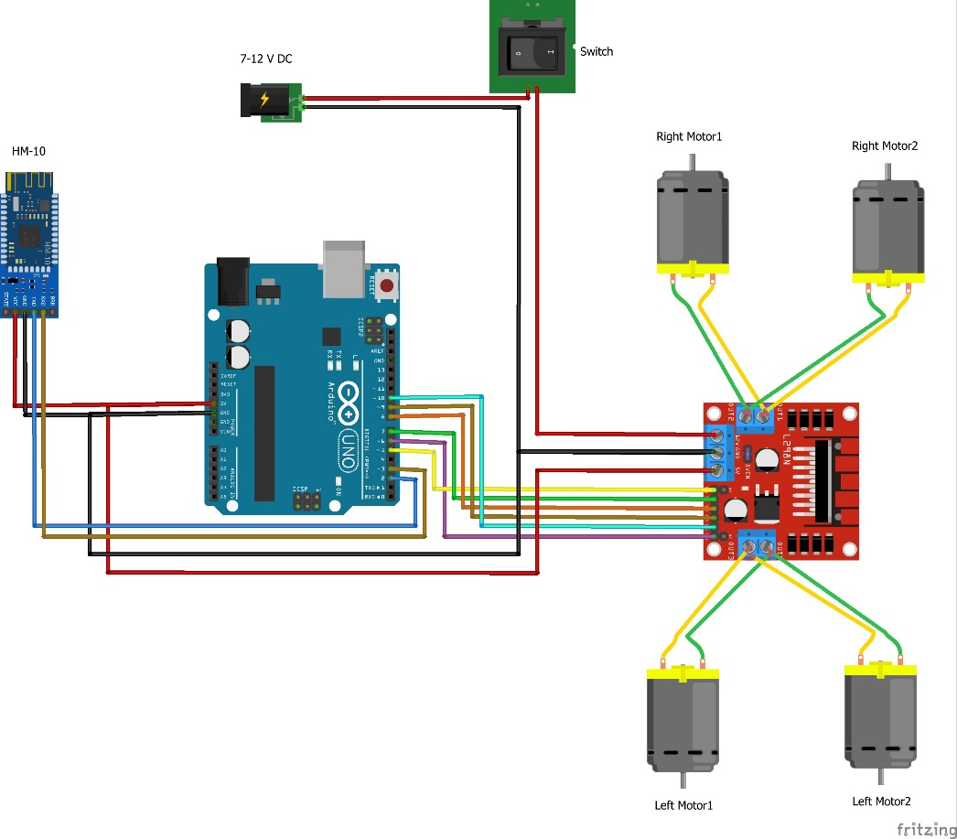

**ESP 32 CAM:**

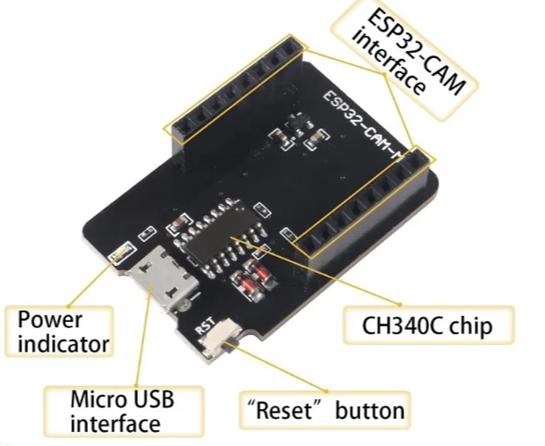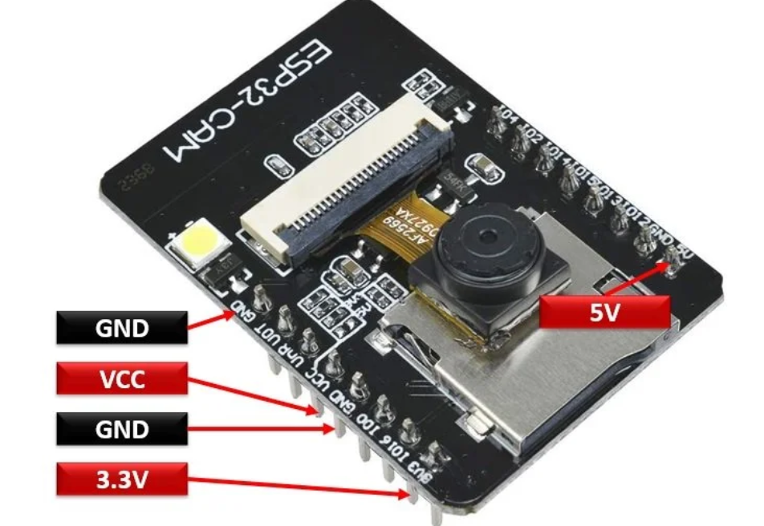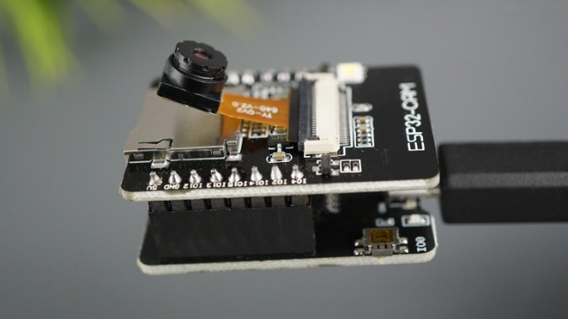

**NODEMCU INTEGRATED WITH AIR QUALITY GAS SENSOR :**

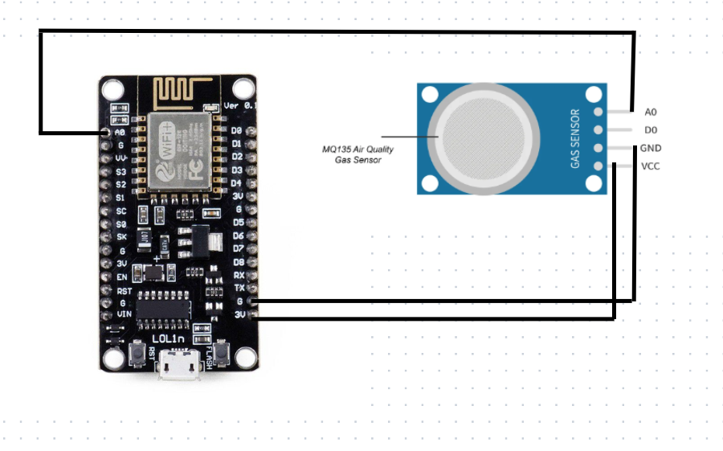

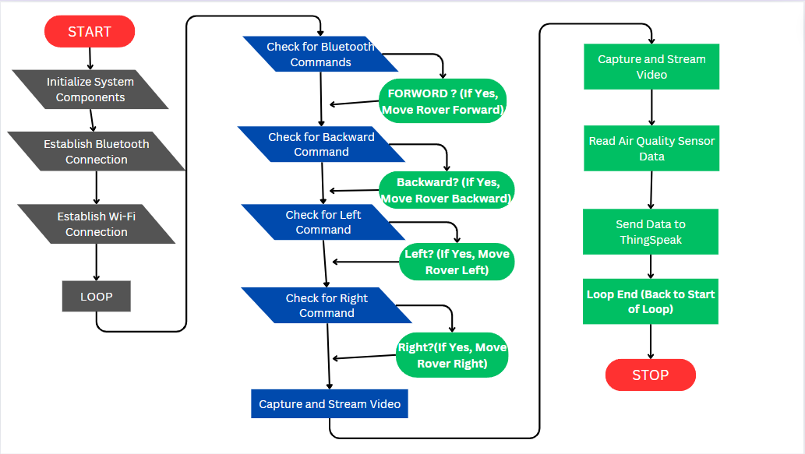**7. Flowchart of the Software:**

**INSTALLATION STEPS FOR ESP32-CAM-MB USB PROGRAMMER:**

***1. Acquire ESP32-CAM-MB USB Programmer:*** *Obtain the ESP32-CAM-MB USB programmer from authorized suppliers or online stores. The package may include the programmer and the ESP32-CAM board itself.*

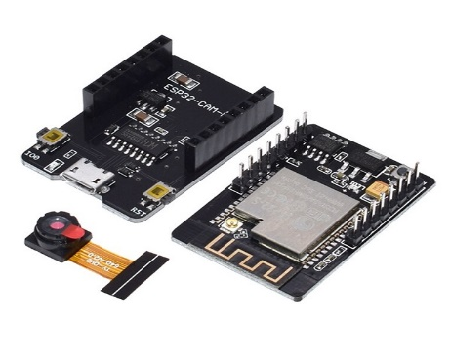***2. Connect ESP32-CAM-MB Programmer****: Attach the ESP32-CAM-MB programmer to the GPIO pins of the ESP32-CAM board. Ensure proper alignment and connection between the programmer and the board*

***3. Install Arduino IDE****: Download and install the Arduino Integrated Development Environment (IDE) on your computer from the official website.*

***4. Install ESP32 Board Support****: Add support for the ESP32 board in the Arduino IDE by following the provided instructions. This step enables programming for the ESP32-CAM module.*

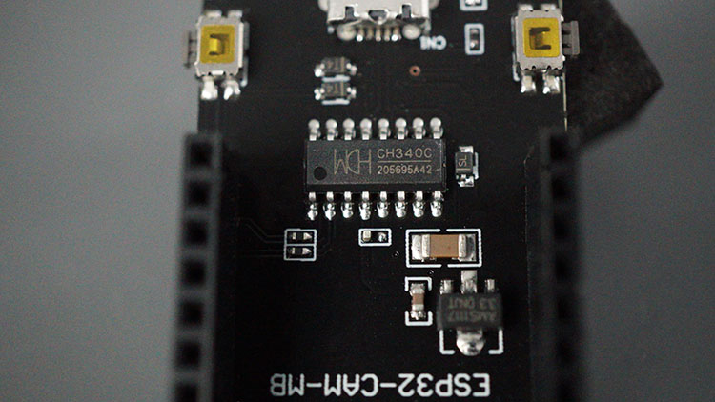

***5. Connect ESP32-CAM to Computer:*** *Use a USB cable to connect the ESP32-CAM board to your computer. Ensure the connection is secure and properly detected by the computer.*

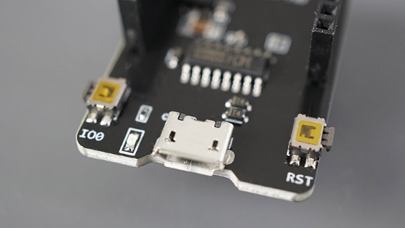

***6. Configure Arduino IDE:*** *Open the Arduino IDE and navigate to Tools > Board. Select "AI-Thinker ESP32-CAM" from the list of available boards. This option should appear if the ESP32 board support was installed correctly.*

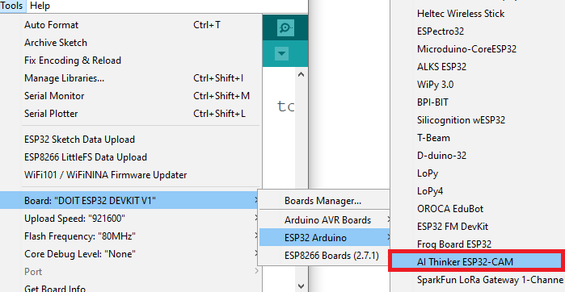

***7. Select COM Port****: Go to Tools > Port and choose the COM port to which the ESP32-CAM is connected. This selection allows communication between the computer and the ESP32-CAM board.*

***8. Upload Code:*** *Write or open the desired code in the Arduino IDE. Click the Upload button to transfer the code to the ESP32-CAM board via the ESP32-CAM-MB USB programmer.*

***9. Verify Upload:*** *Monitor the Arduino IDE console for upload progress and any error messages. Ensure the code is successfully uploaded to the ESP32-CAM board.*

***10. Test Functionality:*** *After uploading the code, test the functionality of the ESP32-CAM board to ensure proper operation. Verify that the desired features, such as camera functionality or sensor readings, are functioning as expected.*

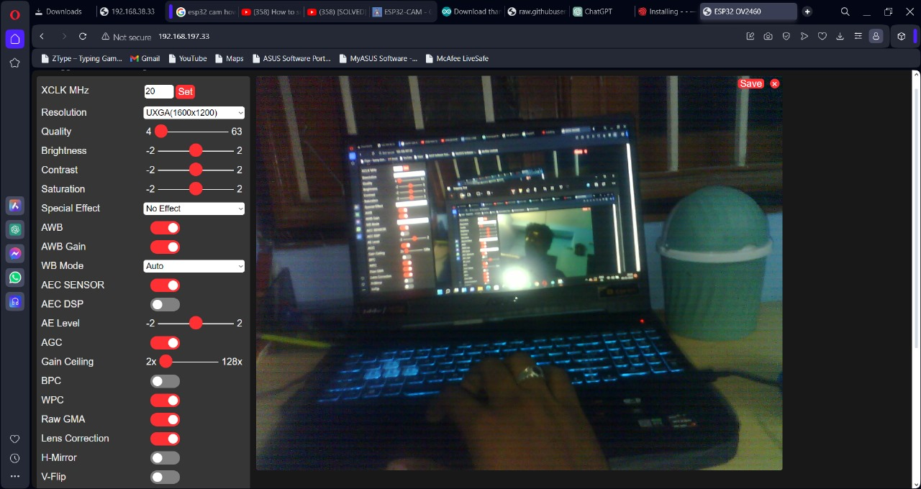

**ESP8266 PUBLISH SENSOR READINGS TO THINGSPEAK**

To publish sensor readings from an ESP32 to ThingSpeak, you can follow these steps:

***1.Sign Up for ThingSpeak:*** *If you haven't already, sign up for a ThingSpeak account at https://thingspeak.com/. ThingSpeak is a platform for IoT applications where you can store, analyze, and visualize sensor data.*

***2. Create a Channel:*** *After signing in to your ThingSpeak account, create a new channel. Specify the fields for your sensor data (e.g., air quality gas sensor) and save the channel settings. Take note of the Channel ID and the Write API Key.*

***3. Install Necessary Libraries:*** *In the Arduino IDE, install the required libraries for the ESP8266 and your sensor*

***4.Set Up ESP32 Code:*** *Write code in the Arduino IDE to read sensor data from your ESP8266. This involves initializing the sensor, reading data from it, and formatting the data to be sent to ThingSpeak.*

***5. Connect ESP32 to ThingSpeak:*** *Use the ESP8266's Wi-Fi capabilities to connect to your local Wi-Fi network. Then, use the ThingSpeak API to send HTTP requests to update your channel with the sensor data.*

***6. Publish Sensor Readings:*** *In your ESP8266 code, use the ThingSpeak Write API Key to send POST requests to update the fields in your ThingSpeak channel with the sensor readings.*

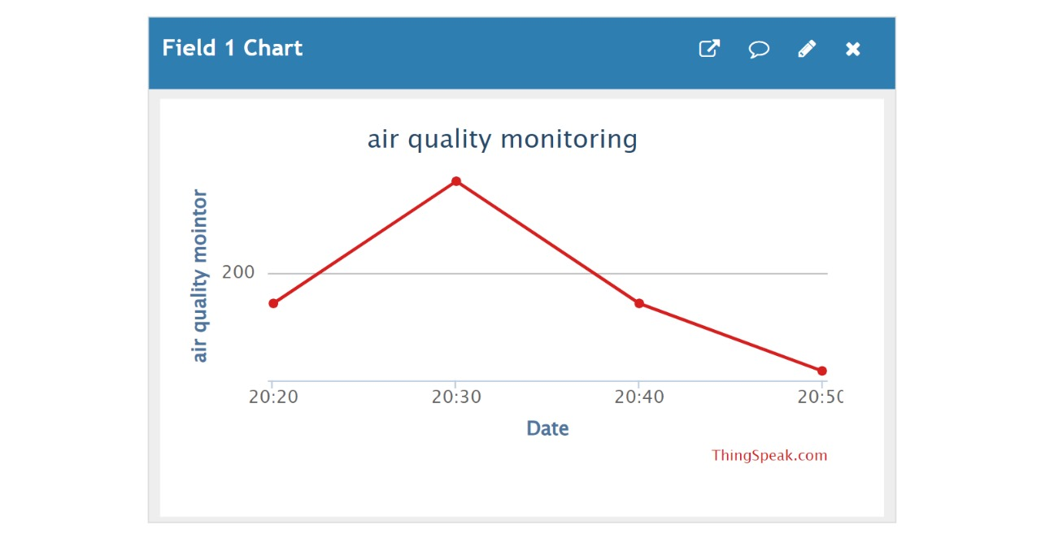

**Timeline for the project:**

| **Week** | **Tasks** |
| --- | --- |
| **Week 1** | **Planning and Research**- Define project scope and objectives- Literature review and research- Assign team roles and responsibilities |
| **Week 2** | **Component Selection and Procurement**- Select components- Order components- Initial schematic design |
| **Week 3** | **System Design and Prototyping**- Hardware prototyping- Software development- Integration plan |
| **Week 4** | **Hardware and Software Integration**- Integrate Bluetooth control- Integrate Wi-Fi video streaming- Integrate air quality monitoring |
| **Week 5** | **Testing and Troubleshooting**- System testing- Debugging- Performance evaluation |
| **Week 6** | **Final Assembly and Optimization**- Final hardware assembly- Code optimization- Power management |
| **Week 7** | **User Testing and Feedback**- User testing- Adjustments based on feedback- Documentation preparation |
| **Week 8** | **Final Testing and Presentation**- Final testing- Complete project documentation- Prepare and practice final presentation- Project submission |

**IMPLEMENTATION**

*Description of the Built System*

*Our project involves building a versatile and functional Scout Rover equipped with the following capabilities:*

***1. Bluetooth-Controlled Movement:***

***- Components:*** *HC-05 Bluetooth module, DC motors, motor driver.*

***- Functionality:*** *The rover is controlled via a mobile app (RC Controller) that sends commands (forward, backward, left, right) to the HC-05 module. The module then relays these commands to the motor driver, which actuates the motors accordingly.*

***2. Wi-Fi Video Streaming:***

***- Components:*** *ESP32-CAM module.*

***- Functionality:*** *The ESP32-CAM captures live video footage and streams it over a Wi-Fi network, created by a phone hotspot. The live feed can be viewed on a phone or computer through a web browser.*

***3. Air Quality Monitoring:***

***- Components:*** *ESP8266 (Nodemcu), air quality sensors (e.g., MQ-135 for gas detection).*

***- Functionality:*** *The ESP8266 collects data from the air quality sensors and sends it to the ThingSpeak platform via Wi-Fi for real-time visualization and analysis.*

***Noteworthy Tools and Techniques***

***- Arduino IDE:*** *Used for programming the microcontrollers (ESP32 and ESP8266) and writing the firmware.*

***- ThingSpeak:*** *A cloud platform for collecting, visualizing, and analyzing data from the air quality sensors.*

***- RC Controller App:*** *A mobile application for sending Bluetooth commands to the HC-05 module.*

***- Web Browser Interface:*** *For viewing live video feed from the ESP32-CAM.*

**Working of the Product**

***1. System Initialization:***

*- Power on the rover using the lithium rechargeable battery for the motors and electronics, and the USB power bank for the ESP32-CAM and ESP8266 modules.*

*- The system initializes all components, establishing Bluetooth and Wi-Fi connections.*

***2. Bluetooth Control:***

*- Open the RC Controller app on the phone and connect to the HC-05 module.*

*- Use the app's interface to send movement commands to the rover. The HC-05 receives these commands and forwards them to the microcontroller, which controls the motor driver to move the rover.*

***3. Live Video Streaming:***

*- The ESP32-CAM connects to the phone's Wi-Fi hotspot and starts capturing live video.*

*- The video stream can be accessed via a web browser by entering the IP address of the ESP32-CAM.*

***4. Air Quality Monitoring:***

*- The ESP8266 collects data from the air quality sensors periodically.*

*- Sensor data is sent to ThingSpeak for visualization. Users can access the ThingSpeak channel to view real-time air quality graphs.*

**Measurements and Feedback**

***- Bluetooth Range:*** *Tested to work reliably within 10 meters.*

***- Wi-Fi Range:*** *Video streaming from the ESP32-CAM remains stable within 15 to 30 meters indoors.*

***- Air Quality Data Accuracy:*** *Verified sensor readings against known standards and calibrated accordingly.*

**User Feedback:**

**- Ease of Control:** *Users found the Bluetooth control via the RC Controller app intuitive and responsive.*

***- Video Quality:*** *The live video feed was clear and useful for navigation and surveillance.*

***- Data Visualization:*** *Users appreciated the real-time air quality data visualization on ThingSpeak, finding it helpful for environmental monitoring.*

**CONCLUSIONS**

***Summary of Accomplishments***

*In this project, we successfully designed and built a versatile Scout Rover with the following key features:*

***1. Bluetooth-Controlled Movement:***

*- Utilized an HC-05 Bluetooth module and motor driver, controlled via the RC Controller app on a smartphone.*

***2. Wi-Fi Video Streaming:***

*- Achieved through the ESP32-CAM module, providing real-time video streaming over a phone hotspot.*

***3. Air Quality Monitoring:***

*- Utilized the ESP8266 (Nodemcu) with air quality sensors to collect and transmit data to the ThingSpeak platform for real-time visualization.*

*These features were effectively integrated, creating a remote-controlled rover capable of providing valuable visual and environmental data for applications such as search and rescue, environmental monitoring, and security operations.*

**Future Improvements**

*While the current implementation meets the project's requirements, there are several areas for future enhancements:*

***1. Enhanced Power Management:***

***- Improvement:*** *Implement more efficient power management techniques and components to extend battery life.*

***- Benefit:*** *Increased operational time and reliability, particularly for long-duration missions.*

***2. Improved Wireless Communication:***

***- Improvement:*** *Upgrade to more advanced Bluetooth or Wi-Fi modules with greater range and stability.*

***- Benefit:*** *Enhanced communication reliability and operational range, reducing the risk of signal loss.*

***3. Additional Sensors:***

***- Improvement:*** *Integrate additional sensors such as GPS for location tracking, LIDAR for obstacle detection, and more advanced environmental sensors.*

***- Benefit:*** *Expanded functionality and increased situational awareness, enabling more complex and autonomous operations.*

***4. User Interface Enhancements:***

***- Improvement:*** *Develop a more sophisticated and user-friendly control interface, potentially including a dedicated mobile app with integrated video feed and sensor data.*

***- Benefit:*** *Enhanced user experience and ease of use, making it simpler for operators to control and monitor the rover.*

***5. Cost Optimization:***

***- Improvement:*** *Explore more cost-effective components and manufacturing methods without compromising quality.*

***- Benefit:*** *Reduced overall cost, making the product more accessible and viable for larger-scale deployment.*

***6. Robustness and Durability:***

***- Improvement:*** *Enhance the physical design to make the rover more robust and capable of operating in harsher environments.*

***- Benefit:*** *Increased durability and reliability, expanding the range of potential applications.*

**TEAM MEMBER CONTRIBUTIONS**

1. ***Project Manager:(JASWANTH V)***
   1. *Role: Ensured effective project coordination and communication.*
   2. *Skills Utilized: Planning, organizing, team coordination.*
2. ***Electronics Specialist:( MANDALAPU SAMANTHA)***
   1. *Role: Designed and assembled the electronic systems.*
   2. *Skills Utilized: Circuit design, soldering, troubleshooting.*
3. ***Software Developer:(BARKAVI E)***
   1. *Role: Developed and integrated the software components.*
   2. *Skills Utilized: Programming, debugging, implementing communication protocols.*
4. ***Mechanical Engineer:(HEMANTH RAJ G)***
   1. *Role: Designed and built the rover’s chassis.*
   2. *Skills Utilized: mechanical assembly, materials selection.*
5. ***Data Analyst and Documentation Specialist:(SANTHOSH S)***
   1. *Role: Collected and analyzed data, prepared documentation.*
   2. *Skills Utilized: Data analysis, technical writing, creating visualizations.*

**ACKNOWLEDGMENTS**

*We would like to express our sincere gratitude to the following individuals and groups for their invaluable support and guidance throughout this project:*

***1. Our Project Advisors, Mrs. M. Anitha and Miss. B.Sivadharahini:***

*For providing insightful advice, encouragement, and expert guidance throughout the development of the Scout Rover project. Your support has been instrumental in helping us overcome challenges and achieve our goals.*

***2. Our Project Preparation Advisor, Vanitha Mam:***

*For your assistance in the project preparation phase, ensuring that our approach and documentation were thorough and well-organized. Your guidance was crucial in shaping the initial stages of our project.*

***3. The College Management:***

*- For providing the necessary resources, facilities, and continuous support that facilitated our research and development efforts. Your support has been essential in creating an environment conducive to our project's success.*

*We are deeply grateful to everyone who contributed to the success of this project. Your support and encouragement have been vital to our achievements, and we hope to make you proud with the results of our efforts.*

**REFERENCE**

**Books:**

* Simon Monk, "Programming Arduino: Getting Started with Sketches", McGraw-Hill Education, 2011. This book provided foundational knowledge on programming microcontrollers used in our project.
* Rafael Valencia, Juan M. Molina, "Robotics: Practical Guide to Robotic Applications", CRC Press, 2020. This book offered insights into the practical applications and integration of robotics.

**Journal Articles:**

* Li, Xia, et al. "Development and Application of Internet of Things Technology in Intelligent Agriculture", Computers and Electronics in Agriculture, vol. 141, 2017, pp. 1-10. This article helped us understand the application of IoT in environmental monitoring.
* Chen, X., et al. "An IoT-based Smart Agricultural Field Monitoring System", Sensors, vol. 17, no. 12, 2017, pp. 2757-2768. This article provided insights into sensor integration and data transmission in IoT systems.

**Manuals:**

* "ESP32-CAM Development Board User Manual", Espressif Systems, 2019. This manual was crucial for understanding the capabilities and programming of the ESP32-CAM.
* "HC-05 Bluetooth Module Data Sheet", Shenzhen HC Information Technology Co., Ltd, 2016. This document provided technical specifications and usage details for the HC-05 Bluetooth module.

**Websites:**

* ThingSpeak Documentation. Accessed at https://thingspeak.com/docs. This website was essential for setting up and using ThingSpeak for data visualization.
* Arduino Official Website. Accessed at https://www.arduino.cc/. This resource provided libraries, code examples, and documentation for programming the Arduino microcontrollers.
* Espressif Systems ESP32 Resources. Accessed at https://www.espressif.com/en/products/socs/esp32/resources. This site offered detailed documentation and development tools for the ESP32.